Dry Eyes – Patient Information Leaflet

Having dry eyes is a very common condition that occurs when the eyes don't make enough tears, or the tears evaporate too quickly. This leads to the eyes drying out and becoming red, swollen and irritated. Dry eye can also be called keratoconjunctivitis sicca or simply “dry eye syndrome”.

Some possible causes of dry eyes include:

Hormonal changes ● Wearing contact lenses

Ageing – as you get older the body produces less tears and eyelids can’t spread tears over the surface of your eyes as well as before

Exposure to the sun, wind or a dry climate may cause tears to evaporate

Activities such as reading, writing or working on a computer may mean you blink less often

Side-effects of some medication ● Laser eye surgery

Medical conditions such as blepharitis, Sjögren’s syndrome, contact dermatitis or rheumatoid arthritis.

NHS England guidance:
NHS England have published guidance which states that dry eyes and sore tired eyes are conditions which are suitable to be managed by patients implementing some self-care measures such as good eyelid hygiene and avoidance of environmental factors alongside treatment.
Most cases of sore tired eyes resolve themselves and mild to moderate cases of dry eye syndrome or sore tired eyes can usually be treated using lubricant eye treatments that consist of a range of drops, gels and ointments that can be easily be purchased over the counter.

Taking care of your eyes – self-care:
Taking care of your eyes is a personal responsibility. Dry eyes are usually a chronic condition and although there is no cure there are things that you can do yourself to help your eyes feel more comfortable and ease symptoms. In mild cases self-care may be all you need.
Things you can do include:

Keeping your eyes clean and maintaining good eyelid hygiene, particularly if you have blepharitis. (Further advice on blepharitis is available at: https://www.nhs.uk/conditions/blepharitis/)

Keeping your eyes protected from wind, dust or other air which can irritate your eyes

Avoid using eye make-up which can block glands that naturally lubricate your eyes

Limiting contact lens use to shorter periods, especially if these cause irritation

Avoiding smoky environments – and stopping if you smoke

Using a humidifier to moisten the surrounding air and avoiding too much time in places with air-conditioning

Drinking plenty of water

If you use a computer for long periods, place your monitor at or below eye level, avoid staring at the screen, and take frequent breaks

And don’t forget to blink, as this helps prevent your eyes drying out.

Taking care of your eyes – over-the-counter treatments:

Treatments for treat dry eyes include artificial tears, tear replacement and “ocular lubricants” – usually in the form of eye drops or gels. If, after trying the self-help methods, you still have symptoms of dry eyes then you can try over-the-counter treatments
The treatments available have different viscosity (thickness), some drops are thin like water and you may need to use them more regularly and others may be thicker gel-like drops which are made from different chemicals and may last longer in the eye. They do the same thing as the ordinary drops but you don’t have to put them in as often.
Finding an effective treatment can vary between people. If one doesn’t work then others can be tried until you find the right one for you. A proper trial of one product would be for at least 6 to 8 weeks.

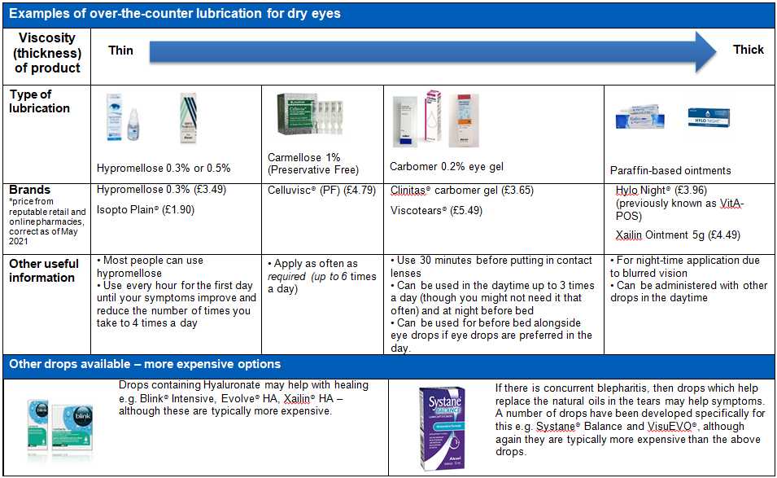
If your symptoms change or worsen then you should see your GP.
How to administer eye drops and eye gels:
- Always wash your hands before and after using eye products
- Tilt your head back a little and pull the lower lid of your eye out to form a “pocket”
  - Administer eye drops into the pocket of the eye.
  - For gels, apply a thin line of gel along the inside of the lower eyelid.
- Close your eyes for a moment and blink to spread the gel. Try not to rub your eyes. Repeat on the other eye.
- To reduce contamination of the bottle, avoid touching the surface of your eye with the nozzle

