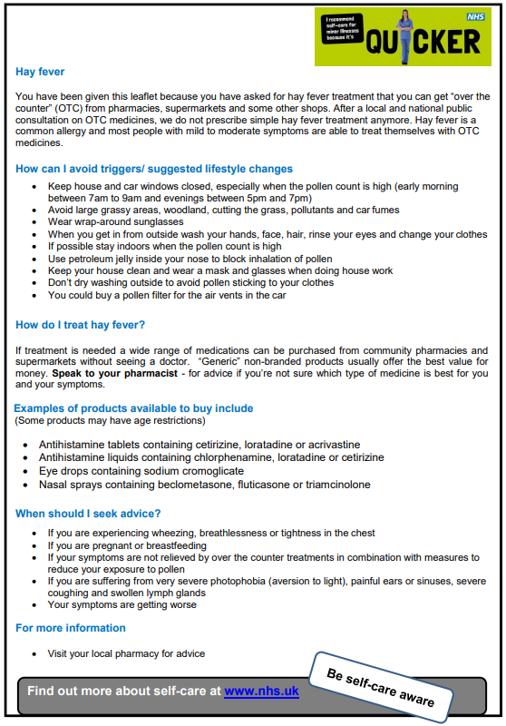
Over-the-Counter Antihistamines Quick Reference Guide (Mild/Moderate Seasonal Rhinitis)
- In line with NHS England guidance on Over-the-Counter (OTC) preparations, hay fever is a self-limiting condition for which the majority of patients is suitable for self- care.
- Oral antihistamines, intranasal corticosteroids and antihistamine eye drops are the usual treatment options for hay fever. All of these products are available to purchase OTC at the same medicinal strength as prescription only products.
- Tree pollen is released between March and September and affects 25% of sufferers; grass pollen, which affects 90% of sufferers, is released from May to late July; and fungal spores are released until September.
- Advice to ALL patients to – Think Pharmacy first; seek support from community pharmacist.
- First line treatments for mild to moderate seasonal hay fever should be purchased OTC for all patients unless specifically excluded on OTC product licence.
- An NHS prescription must not be routinely issued for products available OTC

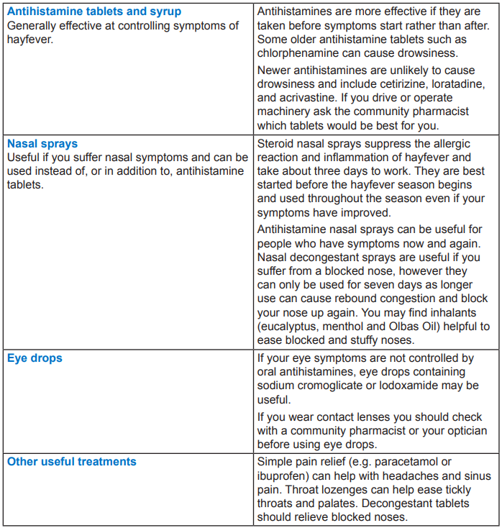

1.NHS England. Conditions for which over the counter items should not routinely be prescribed in primary care: Guidance for CCGs. https://www.england.nhs.uk/publication/conditions-for-which-over-the-counter-items-should-not-routinely-be-prescribed-in-primarycare-guidance-for-ccgs/
2.NHS Choices Live Well (hayfever) - includes information on hay fever in adults and children and hay fever and the weather. www.nhs.uk/Conditions/Hay-fever/Pages/Introduction.aspx
3.NHS Choices Live Well (allergies) - includes information on living with allergies and common allergies and how to treat them, www.nhs.uk/Livewell/hayfever/Pages/Hayfeverhome.aspx

